PO Box 119 Collettesville, NC 28611
336-266-1617 (o/h) 828-754-7067 (camp)
jrvc.org (web), phardy.jrvc@gmail.com (e-mail)

January 10, 2020

Spring forward to the JRVC Mothers Retreat, amidst nesting opportunities for new life. Retreat is on the calendar for April 24-25, 2020, with an optional pre-event “day on the town.” Following is a review of the registration information. The 2020 cost is: $145.00 (rustic cabins); $155.00 (Mt. Zion Cabin - 12 bed total); $160.00 (upper level bunk rooms in Living Units [Shuford & Black], and $165.00 (lower level rooms in Living Units with full bed and a bunk bed). Optional bed & bath linens are available for the Living Units at $5.00 / person. In response to a request from former participants, we are offering an early arrival option on Thursday at 5:30 pm or later. Eat supper before arrival or bring the meal with you. A light breakfast will be served on Friday morning. For this early arrival option add $15.00. Persons choosing this option are planning to tour/shop in the High Country (Blowing Rock to Banner Elk, with lunch on one’s own, and return for dinner at the camp by 6:30 PM on Friday). A $30.00 non-refundable deposit, which applies toward the total cost, is requested for each registration. (If you pay the full amount up front and are unable to attend, the difference would be refunded.) Registrations and inquiries specific to the registration should be directed to me [Phil Hardy] via the office/home number or e-mail address. Questions specific to the program should be directed to Lisa Reece (Packbcker@aol.com). Given various options for lodging, Lisa or I will confirm and / or negotiate -- about a week before the retreat -- regarding the camp’s ability to meet housing requests. It would help Lisa greatly if we can hear from persons by April 6 (I know…, that’s close, so call or e-mail if you are registering near the deadline or late so we can place you on the list) in order for us to adequately prepare. Feel free to copy and share this material. Lisa and I anticipate welcoming all, maybe along with the arrival of robins or Canadian geese, by the waters of the Johns River.

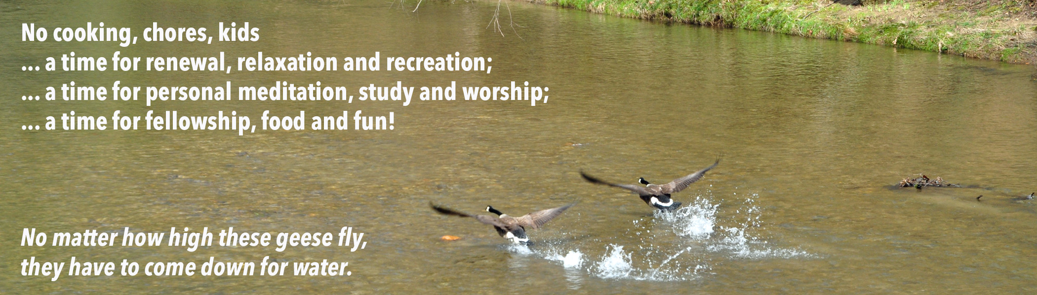
_ _ _ _ _ _ _ _ _ _ _ _ _ _ _ _ _ _ _ _ _ _ _ _ _ _ _ _ _ _ _ _ _ _ _ _ _ _ _ _ _ _ _ _ _ _ _ _ _ _ _ _ _ _ _ _ _ _ _ _ _ _ _ _ _ _ _ _ _ _ _ _ _ _ _ _
2020 Mothers Retreat Registration Form

Name_________________________________ / Address______________________________________

Town_________________ State_____ ZIP________ / E-mail address ____________________________

Home Phone ( _______ ) ______________________ / Cell Phone ( _______ ) ____________________

Local Church (optional) _________________________ / Church Location (town)_______________________

Lodging preference: ____$155.00 Mt. Zion Cabin ____$145.00 rustic cabin

____$165.00 Living Unit (1 & 2 levels ____$160.00 Living Unit upper bunk ____$5.00 bath linen

____$ 15.00 optional Thursday arrival with breakfast and extra night’s lodging

Physical / diet restrictions or comments:____________________________________________________
[use back side for additional remarks, including comments about lodging]
Return completed form with $30.00 registration fee payable to “Johns River Valley Camp” to above address by March 22.
/ Call or e-mail if pushing registration deadline. Thanks!

